EXPERIMENT NO. 8
STUDENT GRADE MANAGER USING STRUCTURES AND FILE HANDLING

NAME: Tejas Mandlik
CLASS: ce-2
BATCH:b
PRN NO. : b25ce1103

PROBLEM STATEMENT:
The objective of this experiment is to design and implement a C program that manages student records using a combination of structures and file handling operations. The program should allow the user to enter student information and store it permanently in a text file. It should also be able to read the stored data and display it on the screen. The goal is to demonstrate how structured data can be written to and retrieved from files using C’s standard input/output library.

DESCRIPTION:
This experiment focuses on using two important features of the C programming language: structures and file handling. A structure allows us to combine related variables into a single data type, which is ideal for storing student details such as name and marks. By storing data in structures, we maintain organized, readable, and reusable code. File handling is used to make this structured data permanent by saving it in an external file. This is done through functions like fopen() to open files, fprintf() to write data, fscanf() to read that data, and fclose() to ensure the file is safely closed after use. In this program, each student’s information is stored in a text file in a simple format such as “Name Marks.” This allows easy storage and retrieval. The program uses a menu-driven approach where the user can repeatedly add records or display all saved records. The experiment reinforces the importance of persistent storage, especially in real-world applications such as student management systems, billing software, inventory records, etc.

RESEARCH:
In software applications, file handling is essential for storing data permanently. Variables stored in memory exist only during program execution, but files store data on the disk, making it available even after the program ends. C provides several file functions for this purpose. The fopen() function opens a file either for reading, writing, or appending; fprintf() writes formatted data to a file; fscanf() retrieves data in a specific format; and fclose() ensures the file is closed properly. Using structures in combination with file handling is a common technique in database systems, report generation tools, and record management systems. For example, student information systems use structures to represent each student and file operations to maintain long-term records. Storing data in plain text format makes the file human-readable and easily editable. This experiment explores how these foundational concepts work together, preparing students for more advanced topics like binary files, data serialization, and full database systems.

ANALYSIS:
To create a simple and effective Student Grade Manager, the program first needs a way to organize data for each student. A structure is used for this purpose, containing fields for the student’s name and marks. This ensures that all related information is grouped together logically. Once the structure is defined, the program uses file handling operations to store the data permanently. When the user chooses to add a student, the program collects the student’s name and marks, stores them inside a structure, opens a file in append mode, and writes the information using fprintf(). By using append mode ("a"), new records are added to the end of the file without deleting existing ones. When the user wants to view stored records, the program opens the file in read mode and uses fscanf() to extract each structure-like record from the file. The data is displayed one by one until the end of the file is reached. Another important part of the analysis is error handling. After every fopen(), the program checks if the file was opened successfully. If not, an error message is shown and the operation is safely stopped to prevent crashes. This makes the program more reliable and user-friendly.

IDEATE:
The idea behind building this system is to simplify the process of storing and retrieving structured student information. The program is divided into small, manageable functions to keep the design modular. One function is dedicated to adding new students. It receives input from the user, stores the values in a structure, and writes them to the file. Another function is responsible for reading and displaying all stored student records. Keeping these tasks separate makes the program easier to understand, debug, and expand. For example, future improvements such as deleting a record, calculating averages, or sorting students alphabetically can be added without rewriting the entire program. The decision to store the data in a simple text format makes file handling straightforward and keeps the file human-readable. Using a menu ensures that the user can repeatedly choose actions until they decide to exit the program. The ideation process focuses on creating a clean, efficient, and practical solution that demonstrates the real-world use of structures and file I/O.

BUILT:
BUILT:
Step 1: Start.
Step 2: Define a structure to store the student's name and marks.
Step 3: Create a menu with three options: Add Student, Display Students, and Exit.
Step 4: When the user selects “Add Student,” accept the student’s name and marks as input.
Step 5: Open the file grades.txt in append mode and write the structured data (name and marks) to the file.
Step 6: Close the file after writing the record.
Step 7: When the user selects “Display Students,” open the file in read mode.
Step 8: Read each stored record from the file using fscanf() until the end of the file is reached.
Step 9: Display each student's name and marks on the screen.
Step 10: Close the file after reading.
Step 11: Repeat menu operations until the user chooses “Exit.”
Step 12: End.

TEST CASES:
Case 1:
Input: Add Student → Name = Amit, Marks = 91.5
Output: Record saved successfully.
Case 2:
Input: Add Student → Name =Vedant, Marks = 78.0
Output: Record saved successfully.
Case 3:
Input: Display Students
Output:
Amit 91.50
Vedant 78.00
Case 4:
Input: Display Students when file is empty or missing
Output: No records found / Error opening file for reading.

IMPLEMENT:
#include <stdio.h>

struct Student {
char name[50];
float marks;
};

void addStudent() {
struct Student s;
FILE *fp = fopen("grades.txt", "a");

if (fp == NULL) {
printf("Error opening file for writing!\n");
return;
}

printf("Enter Student Name: ");
scanf("%s", s.name);

printf("Enter Marks: ");
scanf("%f", &s.marks);

fprintf(fp, "%s %.2f\n", s.name, s.marks);
fclose(fp);

printf("Record Added Successfully!\n");
}

void displayStudents() {
struct Student s;
FILE *fp = fopen("grades.txt", "r");

if (fp == NULL) {
printf("Error opening file for reading! (File may not exist)\n");
return;
}

printf("\n--- STORED STUDENT RECORDS ---\n");
while (fscanf(fp, "%s %f", s.name, &s.marks) != EOF) {
printf("Name: %s\tMarks: %.2f\n", s.name, s.marks);
}

fclose(fp);
}

int main() {
int choice;

while (1) {
printf("\n1. Add Student\n2. Display Students\n3. Exit\n");
printf("Enter your choice: ");
scanf("%d", &choice);

switch (choice) {
case 1: addStudent(); break;
case 2: displayStudents(); break;
case 3: return 0;
default: printf("Invalid choice!\n");
}
}
}

OUTPUT:
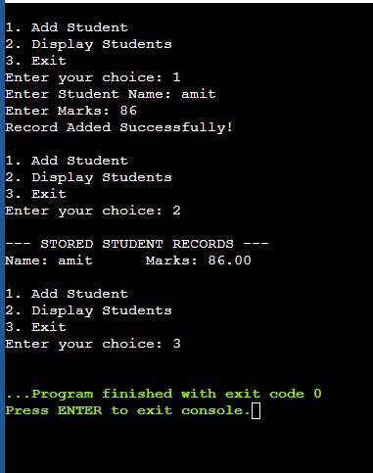
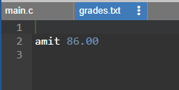

IMPLEMENTATION=

